INTER SERVICES SWIMMING, DIVING AND WATER POLO COMPETITION RESULTS 2018

The Inter-Service Swimming, Diving and Water Polo Championships were hosted by the Royal Navy Amateur Swimming Association at HMS Temeraire from 27 – 29 June 18. The detailed results of the Swimming, Diving and Water Polo are detailed below.

INTER SERVICES DIVING
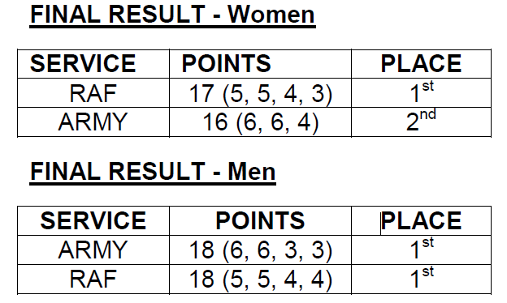

INTER SERVICES WATER POLO
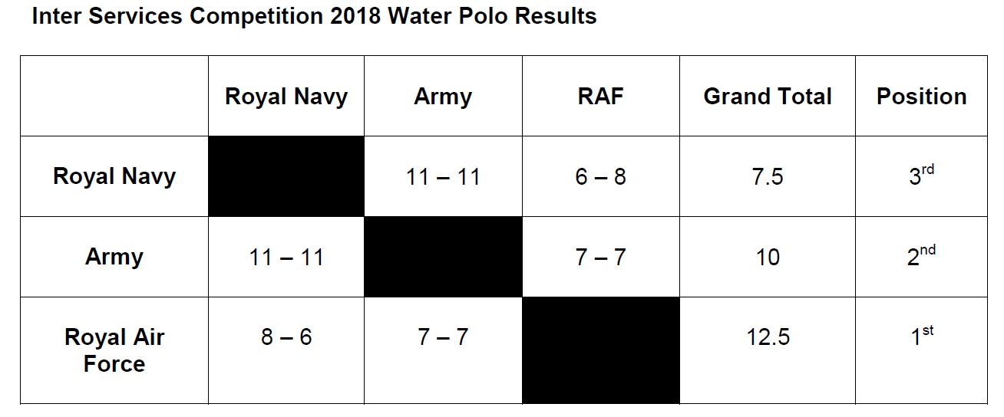

INTER SERVICES SWIMMING
NEW RECORDS SET BY THE ARMY SWIMMING TEAM
SWIMMER | NEW RECORD | PREVIOUS
400m Freestyle (Ladies) LCpl Baker | 4:43.85 | 4:50.15 (06)
100m Freestyle (Ladies) Pte Harkin | 57.88 | 1:00.64 (95)
4x2 Individual Medley (Ladies)  LCpl Baker | 3:25.93 | 3:35.99 (12)
2 Lengths Freestyle (Ladies)  Pte Harkin | 36.32 | 39.05 (15)
4x2 Medley Relay  (Ladies) | 2:54.73 | 2:55.24 (15)
4x2 Freestyle Relay  (Ladies) | 2:39.65 | 2:42.77 (15)

INTER SERVICES CHAMPIONSHIP
